Experiment 2

**Problem Statement:**

a) Write A Shell Program of Hello World

b) Write a shell program to find factorial of a number.

c) Write a shell program to find gross salary of an employee.

d) Write a shell program to display the menu and execute instructions accordingly

* (i)List of files (ii)Process Status (iii) Date (iv) users in program (v) Quit

1)

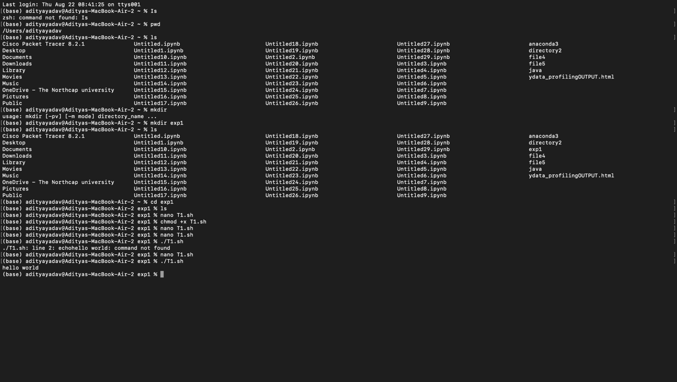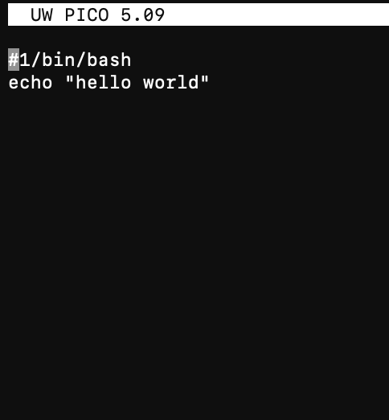

2)

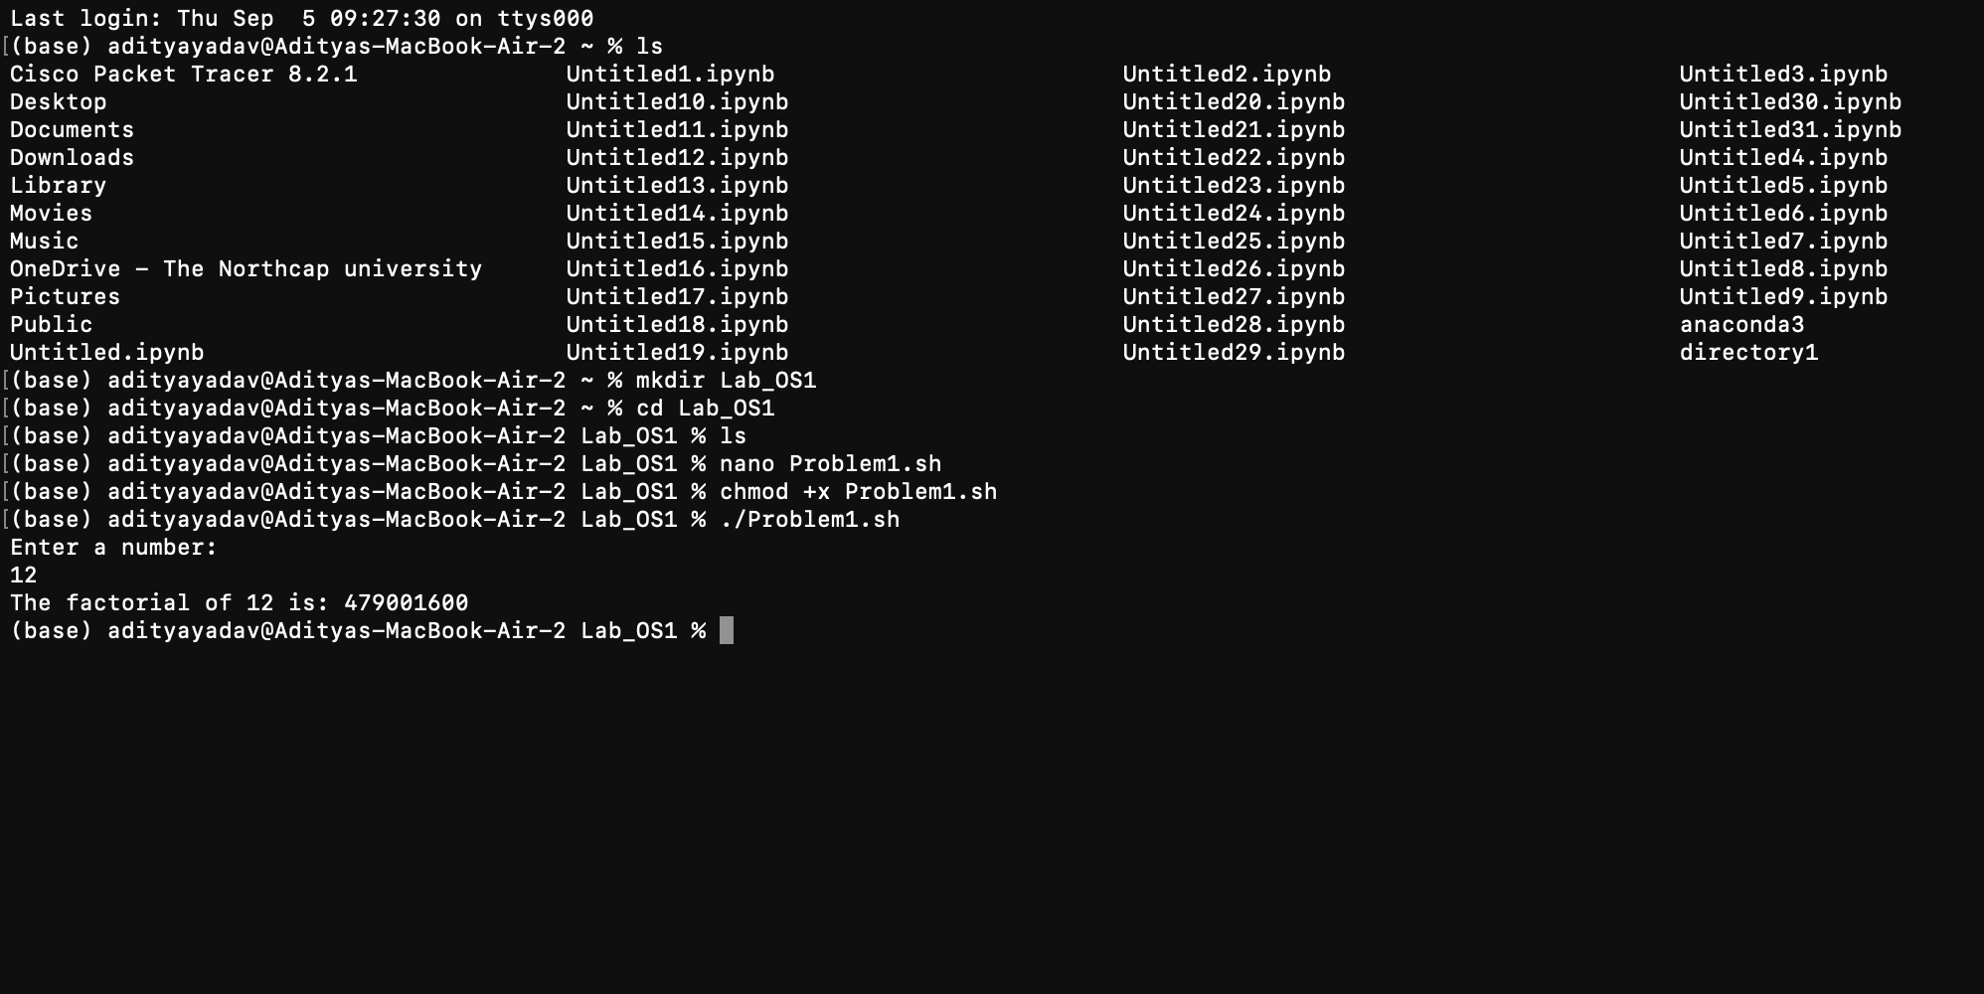

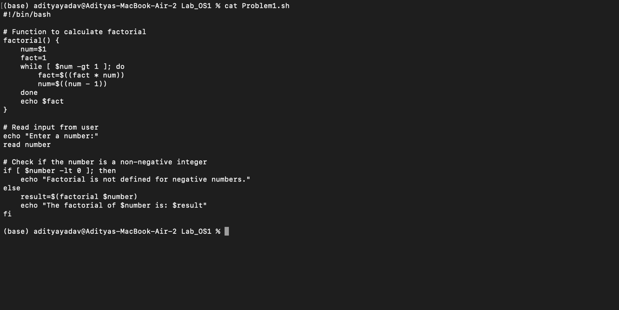

3)

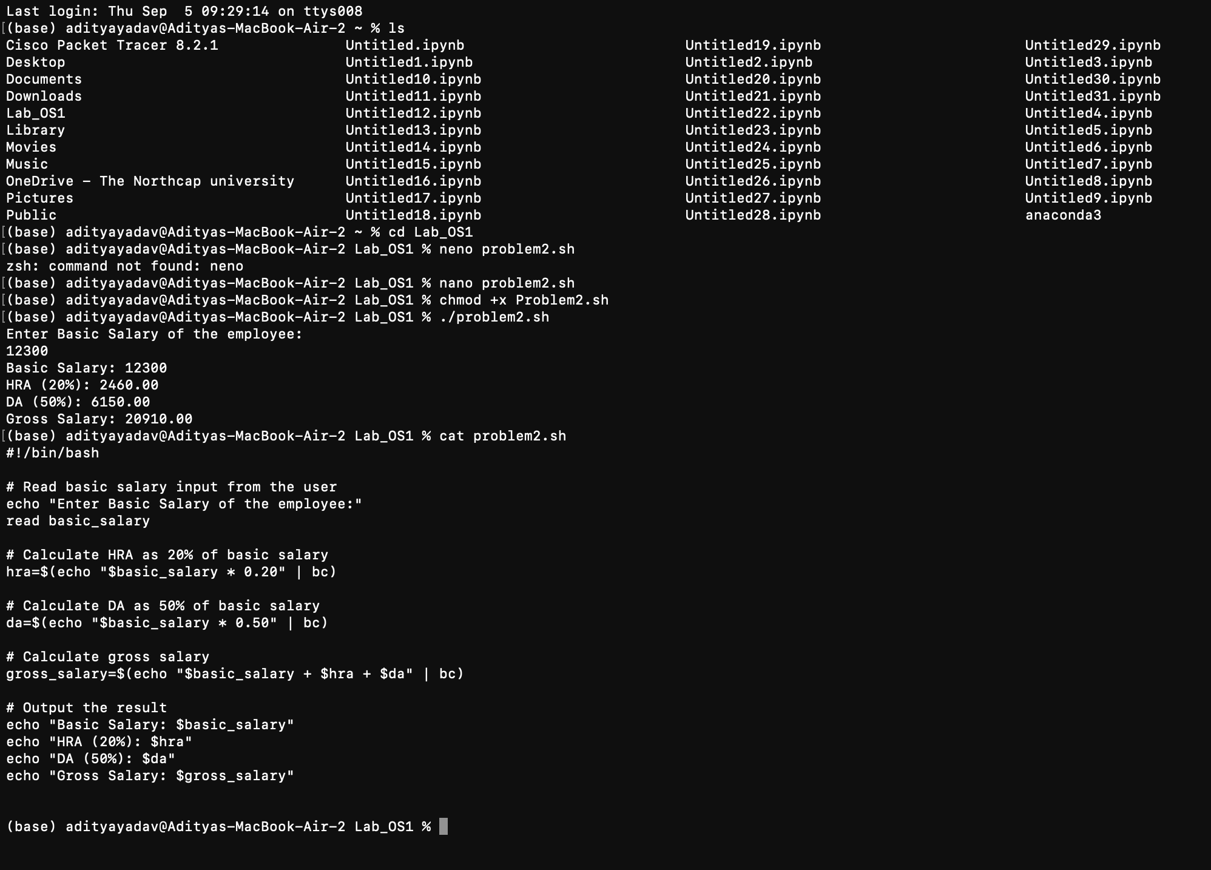

4)

